WEEK – 13 - PASSING ARRAYS AND STRINGS TO FUNCTIONS

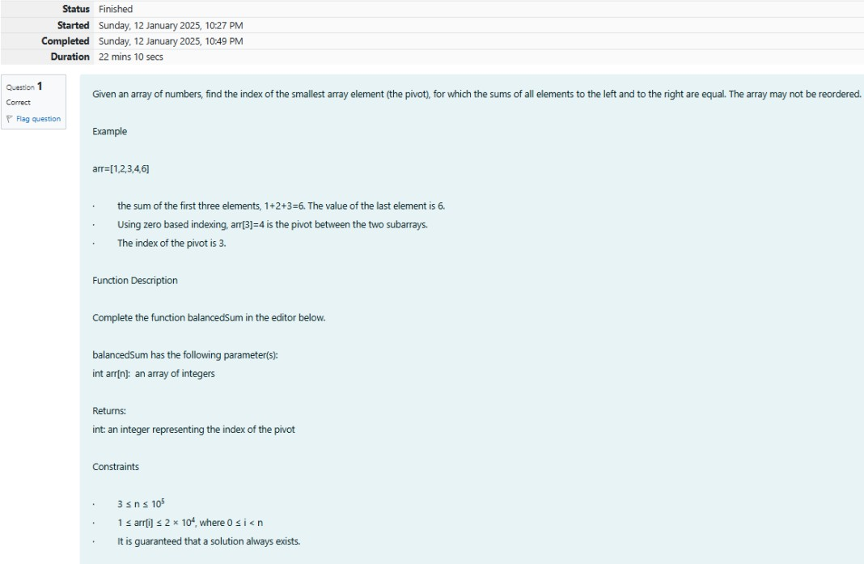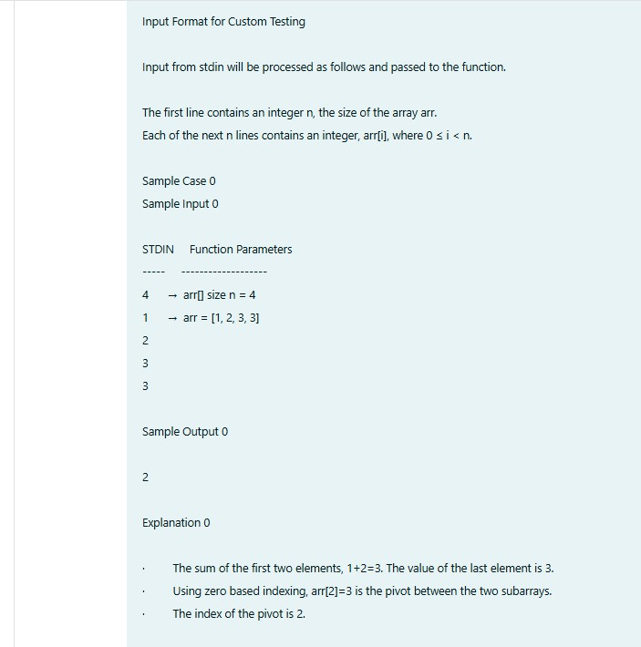REG NO : 240901086 NAME : RENUGADEVI S Q1)

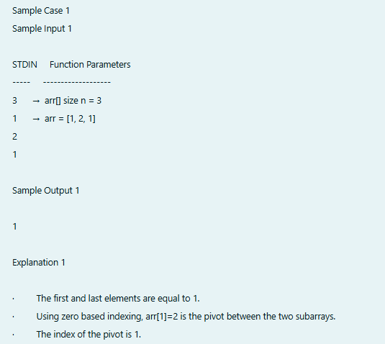

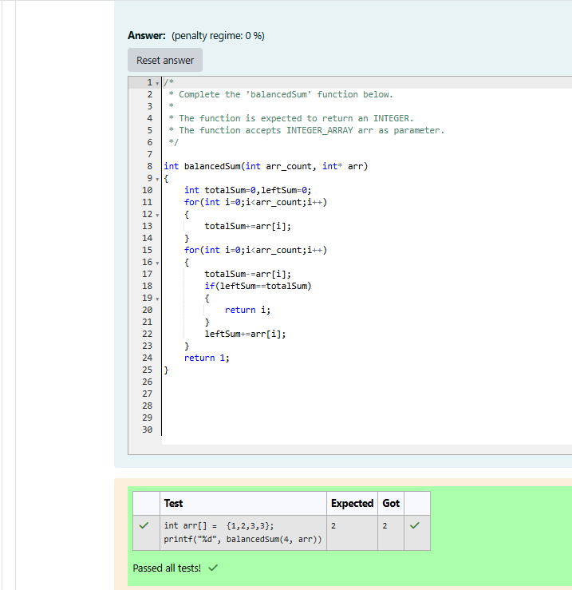

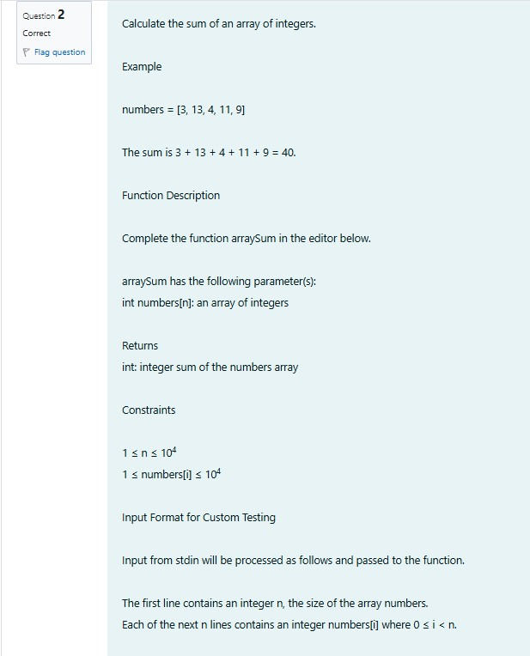REG NO : 240901086 NAME : RENUGADEVI S Q2)

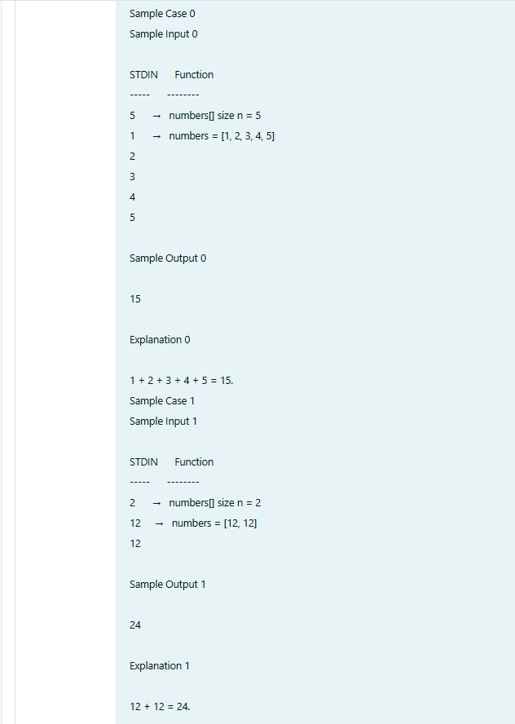

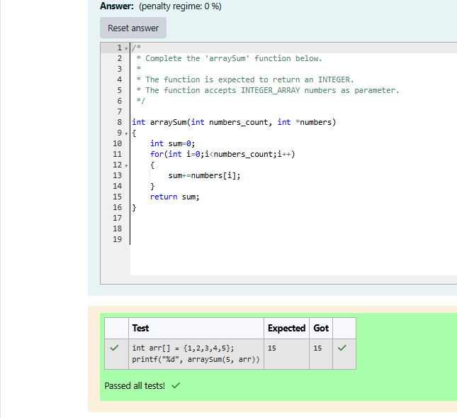

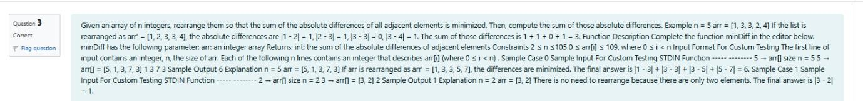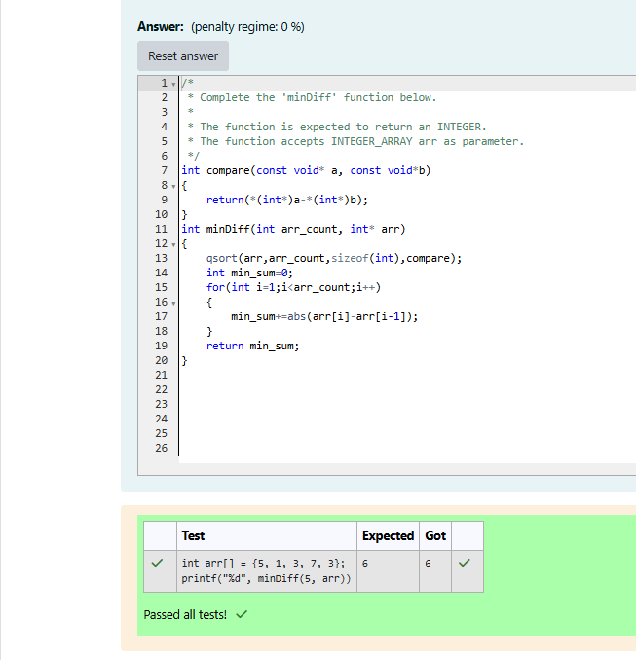REG NO : 240901086 NAME : RENUGADEVI S Q3)